**coffee chain.xlsx**

**data**

1. add a sheet Date > copy Fact!$C > paste Date!$A > remove duplicates > sort Date > add 3 columns Month, Quarter, Year
2. add 4 ranges fact, product, location, date: ctrl+shift+right+down to select range, type name in name box
3. query from 4 ranges: select a range > data > get & transform data > from table/range > power query > close & load to > only create connection > add this data to the data model
4. file > option > add-ins > manage: com add-ins > power pivot
5. create data model: power pivot > manage > diagram view > create one-to-many relationships between dimension tables and fact table using **primary key** and *foreign key*
6. add 4 measures:

% Expenses / Sales = SUM('fact'[Expenses])/SUM('fact'[Sales])

# Inventory Turnover = SUM('fact'[Inventory])/SUM('fact'[COGS])

% Marketing / Sales = SUM('fact'[Marketing])/SUM('fact'[Sales])

% Profit / Sales = SUM('fact'[Profit])/SUM('fact'[Sales])

**schema**

|  |  |  |  |
| --- | --- | --- | --- |
| range | table | column (# distinct values) | formula |
| fact  (KPI) | Fact!$A$1:$N$4249 | *Product Id*  *Area Code*  *Date*  Sales  -COGS  =Margin  -Expenses  =Profit  Marketing  Inventory  Budget Sales  -Budget COGS  =Budget Margin  -Budget Expenses  =Budget Profit | cost of goods sold  selling general & administrative  balance sheet > assets |
| product  (what) | Product!$A$1:$D$14 | **ProductId** (13)  **Product** (13)  **Product Type** (4)  **Product Category** (2) |  |
| location  (where) | Location!$A$1:$D$157 | **Area Code** (20)  **State** (20)  **Market** (4)  **Market Size** (2) |  |
| date  (when) | Date!$A$1:$D$25 | **Date** (24)  Month (24)  Quarter (8)  Year (2) | A2  B2=TEXT(A2,"yyyymm")  C2=D2&"Q"&ROUNDUP(MONTH(A2)/3,0)  D2=TEXT(A2,"yyyy") |

**data model**

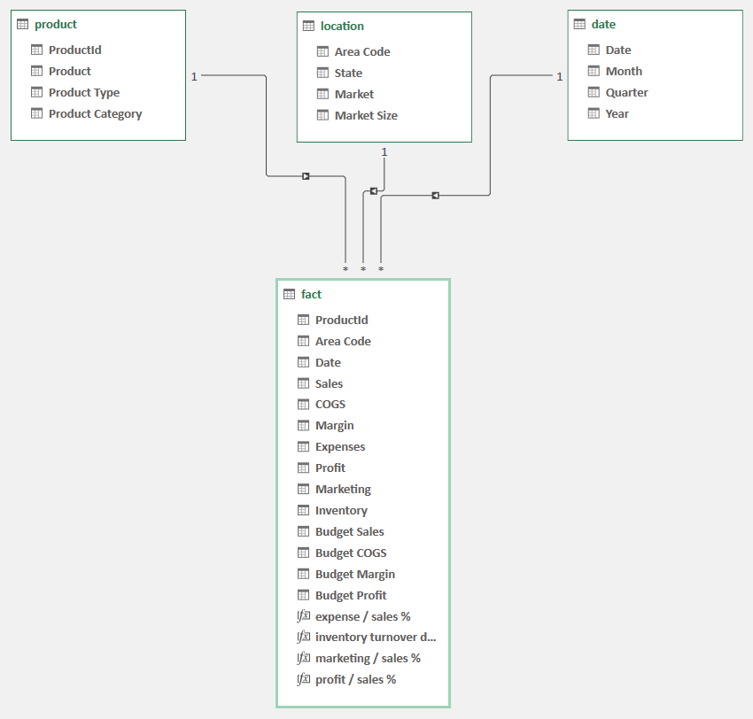

**business**

**questions**

**pivot tables**: insert > pivottable > from data model

dimensions (5W1H) vs measures (KPI)

1. Which Area Code was 25th place in Sales for Espresso? 318

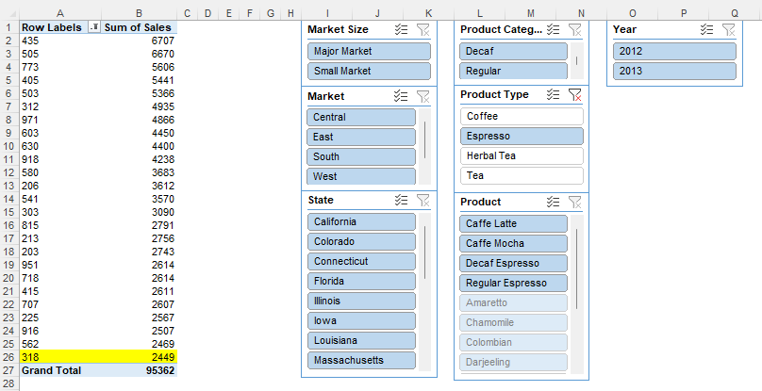

1. Which State in the East Market has the lowest Profit for Espresso? New Hampshire

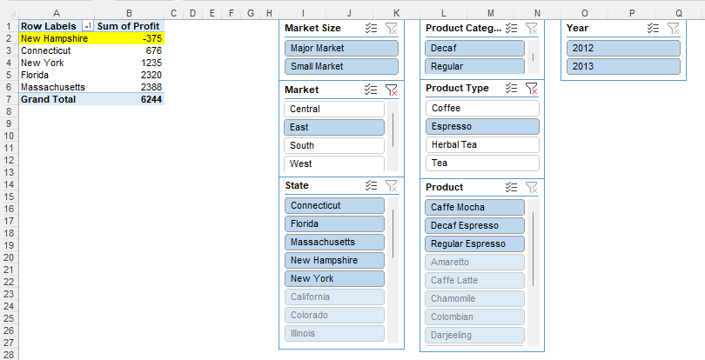

1. What is the difference in Budget Profit, in 2012Q3 from the previous quarter for Major Market? 630

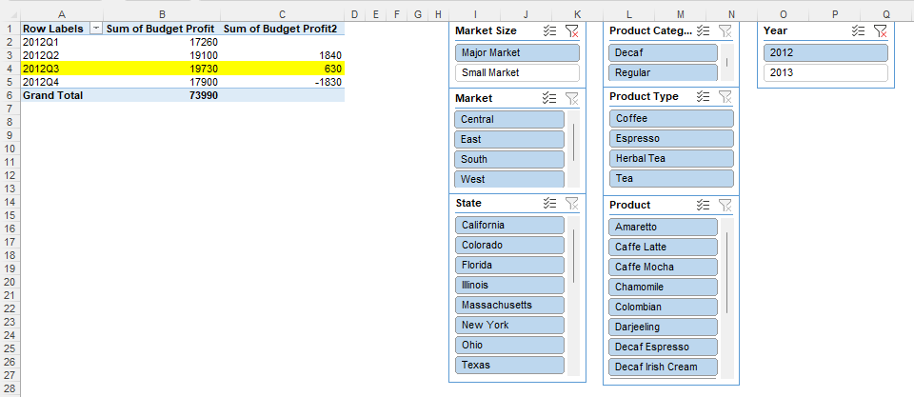

1. In which Month did the running Sales cross $30,000 for Decaf in Colorado and Florida? May 2013

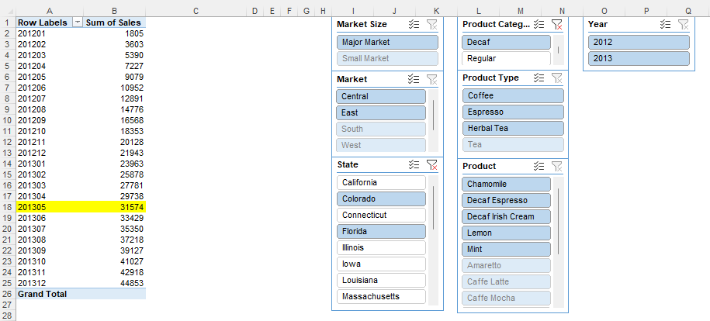

1. Create a bar chart with Product Type, Product, and Profit. Identify which product falls below the overall 99.9% Confidence Interval Distribution (Table across)? Green Tea
2. Using quartiles, identify which of the following Espresso product has the highest distribution of sales? Regular Espresso
3. In 2013, identify the State with the highest Profit in the West Market? California

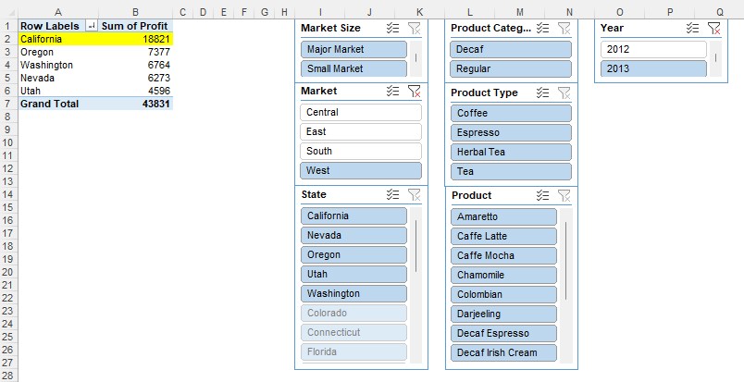

1. Create a scatter plot with State, Sales, and Profit. Identify the Trend Line with ‘R-Squared’ value between 0.7 to 0.8? Polynomial Trend Line with Degree 2
2. Identify the Expenses / Sales % of the State with the lowest Profit. 45.58%

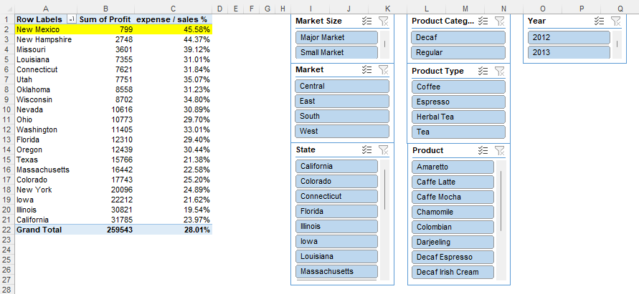

1. Create a Combined Field with Product and State. Identify the highest Selling product and its state. (Colombian, California), (Colombian, New York)

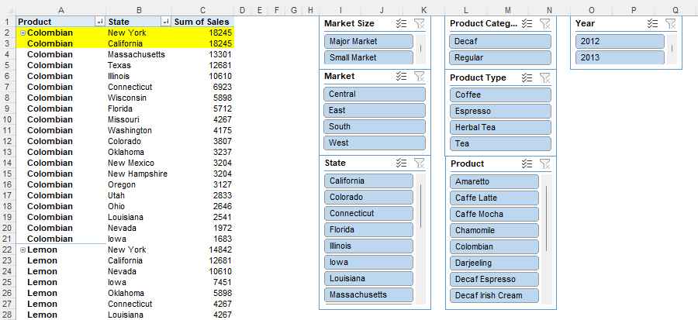

1. What is the contribution of Tea to the overall Profit in 2012? 20.42%

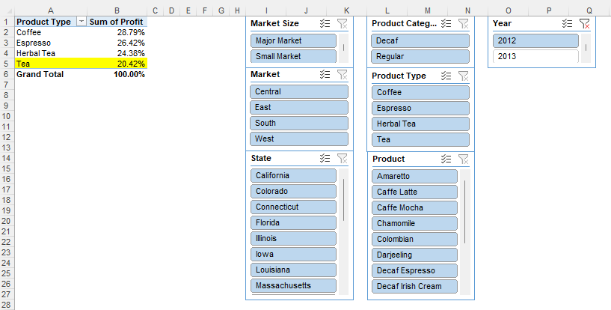

1. What is the average Profit / Sales % for all the Products starting with C? 34.52%

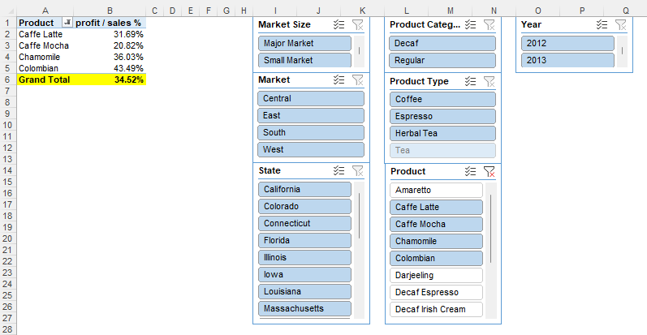

1. What is the distinct count of Area Codes for the State with the lowest Budget Margin in Small Markets? 1

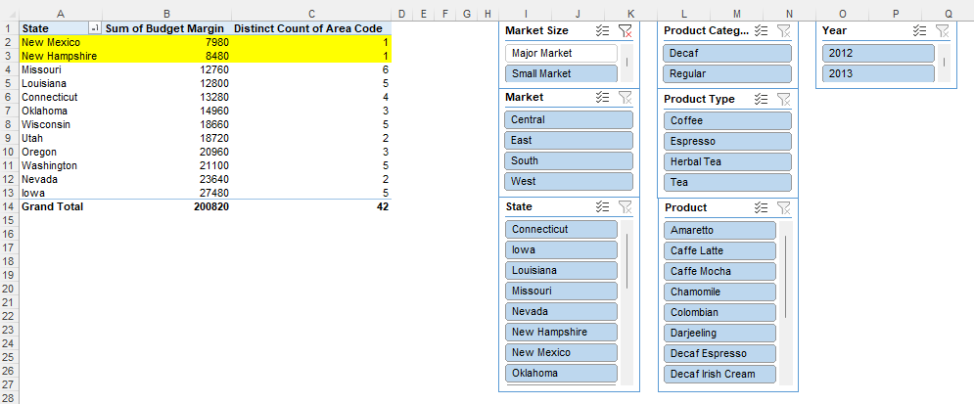

1. Which Product Type does not have any of its Product within the top 5 Products by Sales? Tea

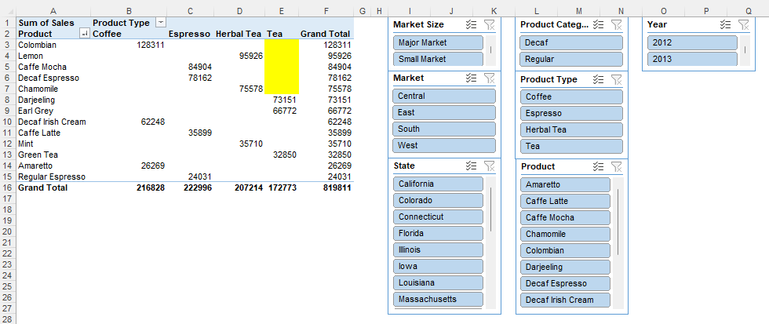

1. In the Central Market, the top 5 Products by Sales contributed _% of the Expenses. 60.92%

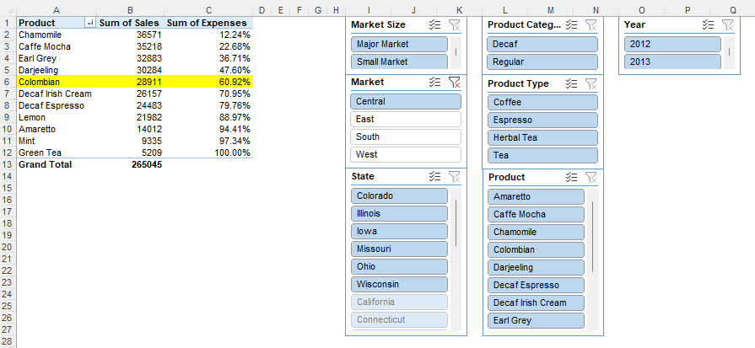

**reports**

**pivottables:** insert > pivottable > from data model > design > grand totals: off for rows and columns

**charts**

|  |  |  |
| --- | --- | --- |
| chart | element |  |
| map | chart title  select data  > chart data range  > horizontal (category) axis labels  > axis label range  legend entries (series)  > series name  > series values  data labels  > more options > label options > lable contains | Sales, % Profit / Sales by State  =Reports!$E$1:$G$21  =Reports!$E$2:$F$21  =Reports!$G$1  =Reports!$G$2:$G$21  =category name |
| scatter | chart title  select data  > chart data range  > series x values  > series y values  data labels  > more options > label options  > values from cells > select range  > select data label range | Sales, % Profit / Sales by Product  =Reports!$N$2:$O$14  =Reports!$N$2:$N$14  =Reports!$O$2:$O$14  =Reports!$M$2:$M$14 |
| bar | chart title  select data  > chart data range  data lables  axes  > more options > vertical (category) axis  > axis options > axis position | Sales, % Profit / Sales by State  =Reports!$E$1:$G$21  =categories in reverse order |
| column-line | chart title  select data  > chart data range  horizontal (category) axis labels  > axis label range  legend entries (series)  > series name  > series values  legend entries (series)  > series name  > series values  axes  > secondary vertical | # Inventory Turnover, % Marketing / Sales by Month  =Reports!$U$1:$W$25  =Reports!$U$2:$U$25  =Reports!$V$1  =Reports!$V$2:$V$25  =Reports!$W$1  =Reports!$W$2:$W$25 |
| waterfall | chart title  select data  > chart data range  Margin  Profit | Actual P&L  =Reports!$Y$4:$AC$5  set as total  set as total |
| waterfall | chart title  selet data  > chart data range  Margin  Profit | Budget P&L  =Reports!$Y$4:$AC$4,Reports!$Y$6:$AC$6  set as total  set as total |

**slicers**: Product Category, Product Type, Product, Market Size, Market, State;

**dashboard**

